

**AMITY INSTITUTE OF BIOTECHNOLOGY**

**MAJOR PROJECT-2022**

**PROJECT TITLE: Deciphering informative multi-omics features using machine learning for precise diagnosis of patients**

**COURSE:** B.Tech Biotechnology-3C

**SEMESTER:** 8th

**NAME OF STUDENT:** Maarib Syed

**ENROLLMENT No:** A0572818006

**BATCH:** 2018-2022

**TRAINING PERIOD:** 61 days

**NAME OF EXTERNAL GUIDE:** Dr. Raghavendran Lakshminarayana

**NAME OF INTERNAL FACULTY COORDINATOR:** Dr. V. Pooja

**Signature of IFC Signature of student**

**Asst. Director & NTCC Convenor** ________________________________________________________________________________________________________ J- 3 Block, Amity University Campus, Sector – 125, NOIDA – Greater NOIDA Expressway, NOIDA – 201 313, Gautam Buddha Nagar (Uttar Pradesh, India) Tel. No. - +91 120 4392195, Fax: 0120- 4392947



**AMITY INSTITUTE OF BIOTECHNOLOGY**

**MAJOR REPORT-2022**

**CERTIFICATE**

On the basis of a declaration submitted by **Maarib Syed**, student of B.Tech Biotechnology, I hereby certify that the project titled **“Deciphering informative multi-omics features using machine learning for precise diagnosis of patients*”*** which is submitted to Amity Institute of Biotechnology, Amity University Uttar Pradesh in partial fulfillment for the award of the Degree of B.Tech Biotechnology, is an original contribution with existing knowledge and faithful record of work carried out by him/them under my guidance and supervision.

To the best of my knowledge this work has not been submitted in part or full for any Degree to this University or elsewhere.

Date

Signature of IFC



**AMITY INSTITUTE OF BIOTECHNOLOGY**

**MAJOR REPORT-2022**

**PLAGIARISM CERTIFICATE**

This is to certify that the Major Report entitled “**Deciphering informative multi-omics features using machine learning for precise diagnosis of patients”.** Submitted by **Maarib Syed** for the partial fulfillment for the award of B.Tech (Biotechnology) Degree has been evaluated by **Dr.V.Pooja,** Internal Faculty Coordinator (IFC).

The Report has **%** plagiarism

**Certificate**

This is to clarify that **Maarib Syed**, a student of B.Tech in biotechnology have carried work presented in the report of the summer internship entitled “**Deciphering informative multi-omics features using machine learning for precise diagnosis of patients**” as a part of the 4th year program in Bachelor of Technology in Biotechnology from Amity University, Noida, Uttar Pradesh under my co-supervision.

_______________________

Dr. V.Pooja

**Declaration**

I, Maarib Syed, student of B.Tech Biotechnology (Batch: 2018-2022) Hereby declaring that I have submitted the project titled “ to **Amity institute of biotechnology**, Amity University Uttar Pradesh, Noida.

The project report has the requisite standard for the practical fulfillment of the undergrad degree. To the best of my knowledge, no part of the project has been reproduced from other report and the content are based on original research.

The author attests that permission has been obtained for the use of any copyrighted material appearing in the Dissertation/ project report other than brief experts requiring only proper acknowledgment of scholarly Writing and all such use is acknowledged.

Date:

Maarib Syed

A0572818006

(Batch: 2018-2022)

**Acknowledgment**

The satisfaction that accompanies the successful completion of any task would be incomplete without the mention of people whose careless corporation made it possible, whose constant guidance and encouragement crown all efforts with success. I would like to thank **Pine Biolabs** and **Prof (Dr) Chanderdeep Tandon,** Head Off department-AIB, and amity university for allowing me to undertake the project. I would like to thank my industry mentor **Dr.** **Raghavendran Lakshminarayana** who is the driving force behind my successful completion of the project. He Has been always there to solve any query of mine and also guided me in the right direction regarding the project. Without her help and inspiration, I would never have been able to complete the project. I would like to extend my gratitude to thank **Dr.V.Pooja**, Internal Faculty Coordinator, Who has been an encouraging mentor throughout the summer internship program.

**Abstract**

Liver cancer is one of the most common malignant tumours and is the second most cancer leading to mortality. It is the 4th most common cancer that causes death worldwide with a annual rate of 700,000 deaths recorded globally in recent years.

Liver cancer initiates in the labour and there is more than one type of primary liver cancer i.e HCC (Hepato cellular carcinoma). HCC is accountable of nearly 75% to 85% of liver cancer deaths worldwide.

**HCC is the prominent form of liver cancer.**

There is another type of tumor that is Cholangiocarcinoma it is present in bile duct and is accountable of 10 to 20% of cases in liver cancer.

As we know liver cancer is a global health concern that are estimated to be >1 Million cases by 2025. HCC is the common form of liver cancer which accounts about ~90% of total cases worldwide. Some infections like hepatitis C and hepatitis B viruses are the main factors responsible for the development of HCC.

even though there are other factors that are responsible for liver cancer like metabolic syndrome or diabetes millitus are more re occurring factors for HCC molecular structure to activate.

**1 Introduction:-**

The TCGA pan cancer project is a way to assemble thousands of data for the patients with primary tumours that are present in different tissues on different sites of body. It consists of 33th types of tumours such as breast carcinoma,lymphoblastic acute myeloid leukemia (LAML), bladder carcinoma (BLCA), and rectal adenocarcinoma etc.

The data sack was created using omics characterization in which data across the platforms that are linked by same data to maximise the potential of centripetal analysis. The use of data enables different identification factors or general trends that include common pathways, regulatory hubs or deactivated tissue types.

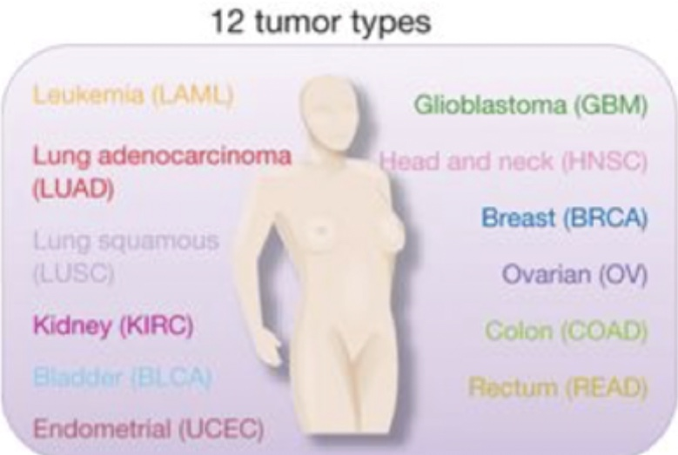TCGA contributes the data from multi-omics layers i.e MiRNA sequence, RNA sequence, DNA sequence or copy number variation (CNV). Even TCGA maintains clinical trials and different demographic reports or information of various cancer patients

* 1. Pan Caner Analysis

When the molecular changes take place inside or among tumours that are based on tissue, transcriptomics signatures vary with different types of tissues example (liver cancer versus breast cancer).

Even tumours or non-tumours samples have different cancer and can be distinguished based on transcriptomics data.

Pan-cancer analysis can be obtained by different bioinformatics tools

1. Factor Regression Analysis
2. Principle Component Analysis (PCA)

It also aims to examine similarities between genomics and cellular alterations and to differentiate tumour types.

Pan cancer studies can detect different genes which can mutate from conducive to oncogenesis, with recurrent genomic structures between different tumours. It is necessary to standardise different data between various platforms to establish the criteria between research work of data and present results.

Omics data allows fast and quick identification for the quantification of millions of molecules from a single experiment.

Even though all the cancers are molecularly distant but have many common shares that drive mutation. The pan-cancer analysis allows frequently mutated genes with abnormalities of other genes that are common in many different cancers, regardless of the tumour origin. Using next-generation sequencing (NGS), and pan-cancer analysis such as the tumour genome Atlas can contribute to understanding DNA and RNA between various cancer types.

 Pan-cancer analysis with NGS panels helps researchers to enable different and comprehensive analysis that defines the set of gene variations that are associated with many or different common cancers, that include tumour or non-tumour malignancies.

Cancers that are driven by genetic change are more likely to be parallel with sequence that enables different documentation in the whole genome scale of variation. Genome analysis are the matching tissue across tumours that are described by the generation of cancer that clustered bid different structural variation in a single catastrophic event.

**2 Review of Literature**

# An overview of Liver Cancer

The main factor responsible for hepatocellular carcinoma (HCC) are hepatitis C and hepatitis C (HCV), it is a type of primary liver cancer which is mostly abundant in people born between 1945 to 1965. As it is observed that HCC causes several deaths worldwide. In the early stages of liver cancer it can be cured by surgical methods, liver transplant or by giving local ablation so that the patient can improve. However, if the disease are detected in early stages there are more therapies for the survival of the patients quality of life.

Researchers are investigating several molecular biomarkers and the most high relability is Golgi 73 (GP73) Protein, TP53 Protein, Osteoprotein (OPN), Glypican-3 (GPC3), MicroRNA’s etc. The main function of micro RNA is to regulate carcinogenesis for pathways of tumor progression.

In the presence of chronic HCV infection the risk of duplication of HCC was take mecompared with only infection alone. It he was observed that women are more susceptible to liver cancer which can develop cirrhosis as compared to men, because of hormones i.e estrogen.

In the liver acetaldehyde it's formed by metabolised alcohol, which is toxic in nature that result in the formation of adducts that causes mitochondrial damage. There have been recent studies for the promising biomarkers of HCC such as GPC3, OPN, GP73, VEGF, EGF, IGF gene are the most potential biomarkers related to different pathways to HCC.

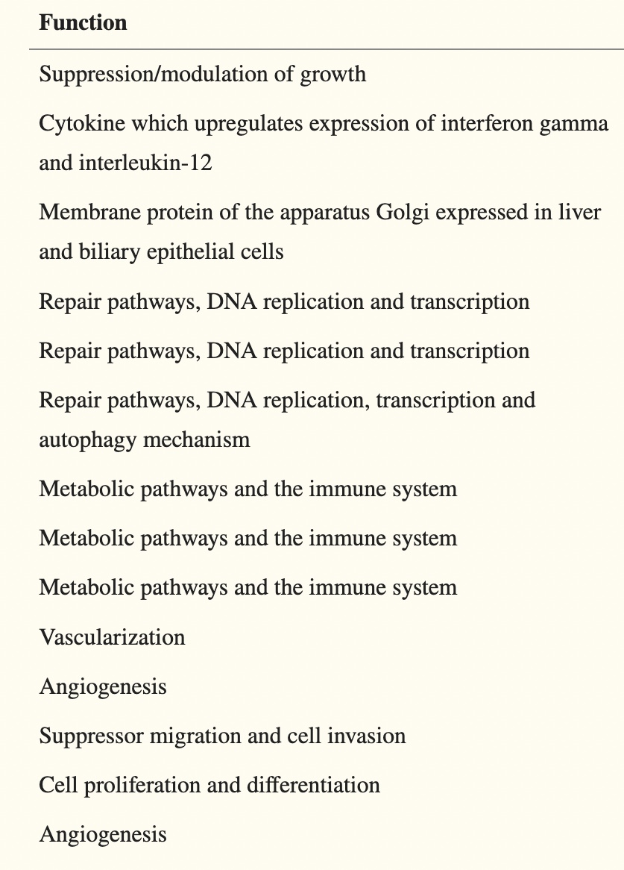

2.2 Causes

Even though liver cancer can happen in any age, but is most common among the age group of 60 and above.

* Smoking recklessly
* Heavy drinker (consumption of alcohol)
* Having cirrhosis
* Overweight
* Diabetes (type 1)
* Inherited liver disease
* Chronic infection
* Long term in digestion
* Liver stones
* HCV & HBC

2.3 Risks Factors

HCC carcinogenicity with liver cirrhosis is associated from chronic liver cancer as HBV or HCV infection or autoimmune hepatitis. The risk factor involved in HCC development is quite high in male gender because of the age, obesity or co-infection.

A research was conducted that shows the increased risk of HCC development was independent to alcohol consumption ~2.1%. The associated infections were HBV & HCV that increase the risk of HCC development ~1.7%.

NASH

Alcohol Consumption

NAFLD

Ingestion

Tabacco

Genetic disoder

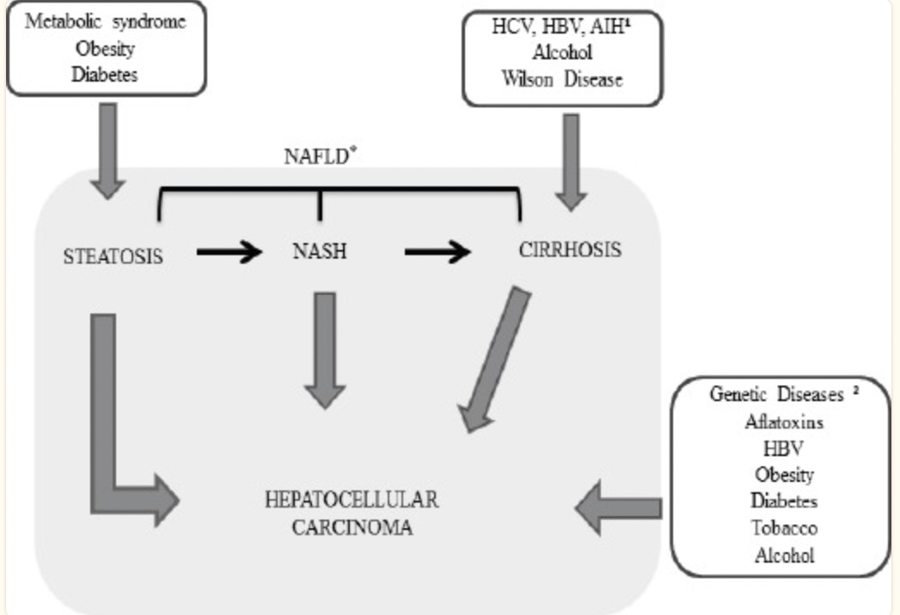

2.4 OMICS LOGIC

OmicsLogic is a program that embeds data-driven concepts into biological projects, spanning the student learning journey from observer to participant in research. This journey begins with identifying an interesting biological research problem or question that can be answered with data, continues with the collection and organization of data, and concludes with students interpreting and drawing conclusions about the data. OmicsLogic programs are developed using project-based content that is enriched with multimedia content. These are divided into 5-10 minute modules with videos, quizzes and assignments that can be completed independently. All commonly used omics data types are explained from a biological and data analysis perspectives.

2.3 TARGET IDENTIFICATION AND SCREENING

Target identification and screening A key step in the development of new pharmaceutical drugs is that of identifying direct molecular targets (such as protein or nucleic acid) of the bioactive compounds and distinguishing these from all other gene products that respond indirectly to the drug targets. In clinical pharmacology, target identification is aimed at finding the efficacy target of a drug/pharmaceutical or other xenobiotics. The techniques used may be based on principles of biochemistry, biophysics, genetics, chemical biology, or other disciplines. In the upstream direction, bioinformatics and reverse docking methods are usually used for target identification.

Tools like information technologies and chemoinformatic Tools are the basic need of the artificial and human intelligence interaction dad can't detect patterns, by which computer algorithms failed to do so. Whereas There are many settings like data-intensive, And cognitively complex settings dad guide or make decisions rapid, efficiently and gives output/ result in real-time. big data requires filtering by interpretation. Many biomedical scientists need effective collaboration and divisions.It can also be studied through network-based drug discovery. Where The levels of information drug-protein and disease network.

2.4 Factors Affecting Omics-Logic/Machine Learning:

* OnO data integration
* Presence of intraction
* Fairness of models
* Intergration of large data
* Heterogeneityof non-omics data

2.5 Factors to be considered in Omics-Logic/Machine Learning:

* Etracting large data
* High dimensional data
* extracting meaningful data
* Roles
* Relationships
* Various data sets

2.7 Advantages of Machine Learning

* Helps in Identifying Diseases and Diagnosis.
* Drug Discovery and Manufacturing.
* Medical Imaging Diagnosis.
* Personalized Medicine.
* Machine Learning-based Behavioral Modification.
* Smart Health Records.
* Clinical Trial and Research.
* Data Collection.

**3 Methods and Methodology**

**NCBI- National Centre For Biotechnology Information**

It is a Information Center which is a part of United States National Library for medicine. This National Center is approved by government and even funded buy them. it consists of series of database which is relevant for biomedicine and biotechnology, it is an important resource for bioinformatics tools and services.

<https://www.ncbi.nlm.nih.gov>

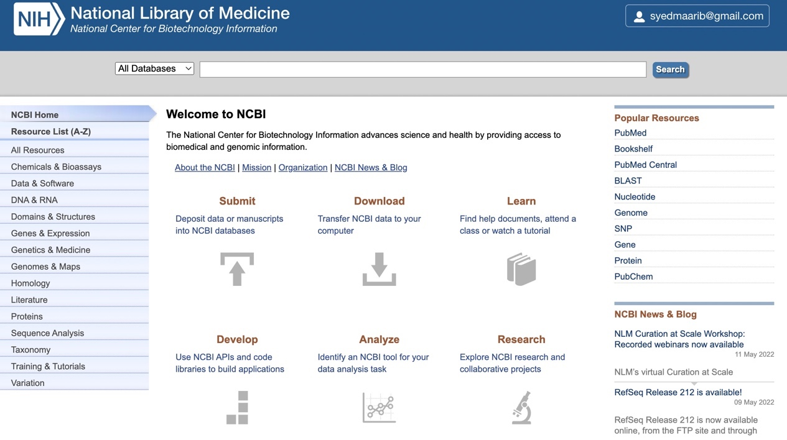

**FIG-1 NCBI Database**

**GDC Data-portal**

It is a portal that robust the data which is driven that allows the user to search and download the cancer related data by using machine learning or modern web technologies.

It provides the platform for seamless, efficiently quiring antu download high quality and complete data.

<https://portal.gdc.cancer.gov/>

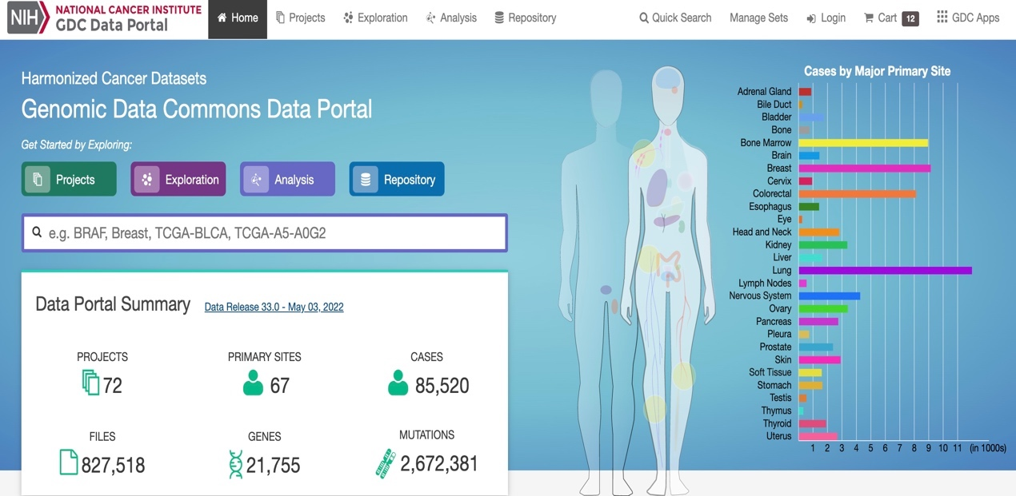

**STEP1:- ENTER RESPECTIVE NAME IN SEARCH BAR.**

Cancer:- LIVER CANCER

Gene:- TP53

Organism:- Homo sapiens (human)

Type:- Protein Coding

**FUNCTION**

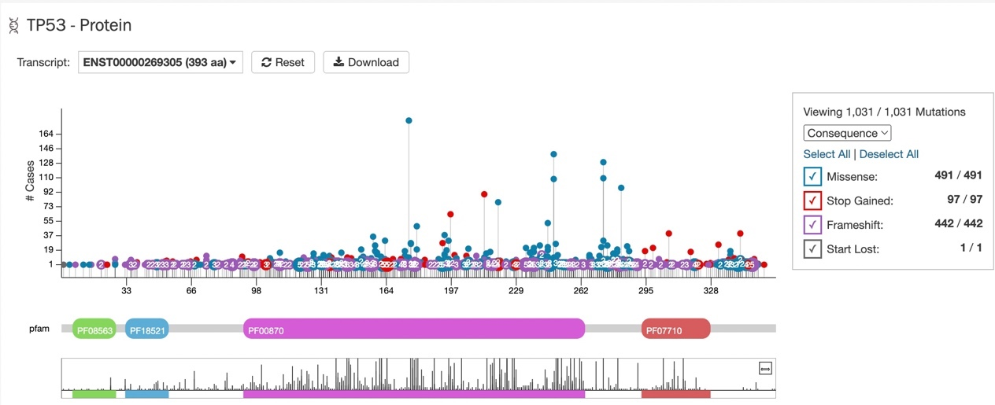

The protein has a unique structure that activate binding molecules. The TP53Activating protein has transactivation domain.

TP53 gene lead to increase of abnormal hormone or cells leading to formation of cancer. Hepatitis virus is responsible for the change of DNA that infact liver cells.

**PUB CHEM**

It is a chemical molecule and biological affairs database that provides data and papers related to healthcare. It is maintained by NCBI (National Center of biotechnology information).

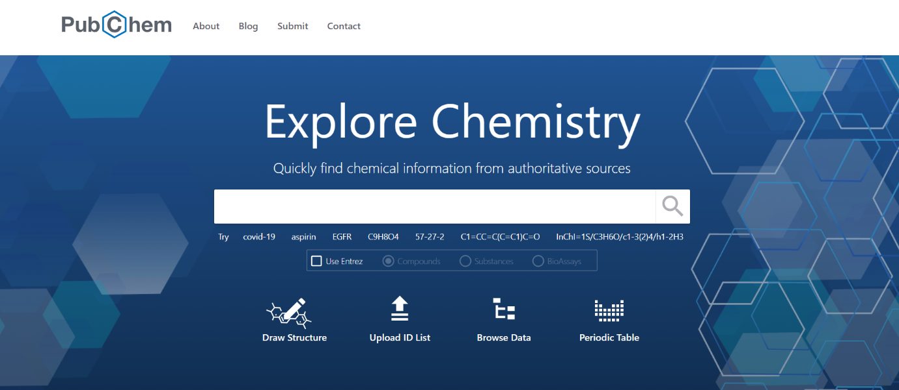<https://pubchem.ncbi.nlm.nih.gov>

**FILE BROWSE**

It is a companion portal for the broad institute GDCA. It analisis pipelines which develop the cull that analyse the data that is generated by The cancer genome Atlas (TCGA). It Characterise and identify genomic patterns for cancer models in humans.

It provide the sample that are capable of visualising and exploring the programs that are most comprehensive and are characterised to open cancer data set

<http://firebrowse.org/?cohort=LIHC&download_dialog=true>

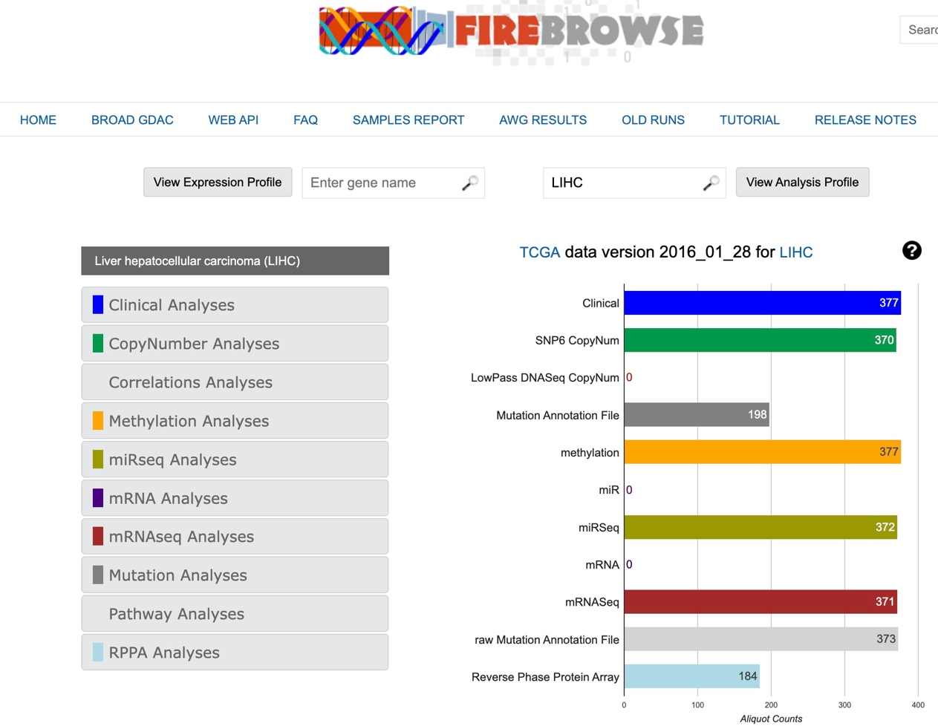

**T- BIOINFO SERVER**

It consists of various data types that have different sections of the platforms. It is a multi-omics research platform that are designed to access researchers to analyse, modelling and to visualise the biological data. It is built to handle clinical data, genomics, structural data, proteomic, etc.

<https://server.t-bio.info/>

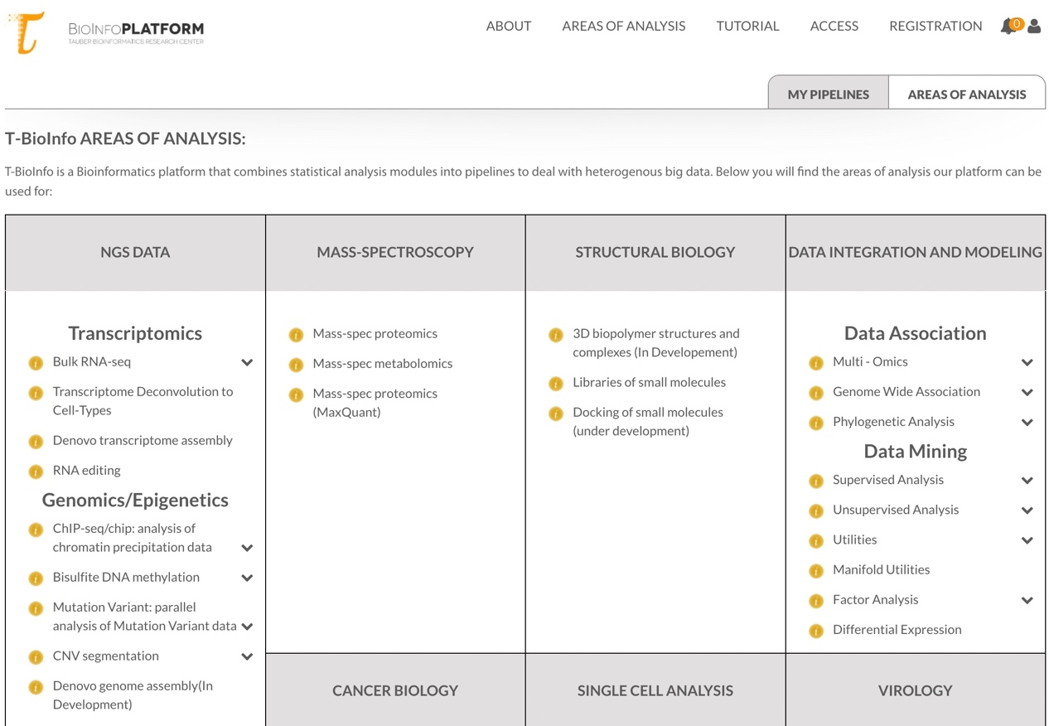

**4 RESULTS**

**Exploratory Data Analysis Using PCA**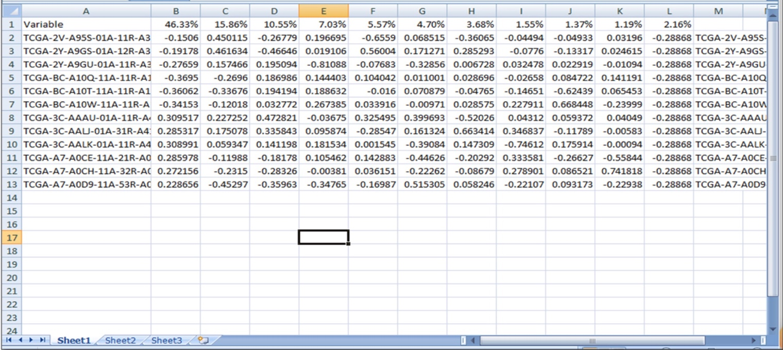

Figure:- Resultoutput of PCA

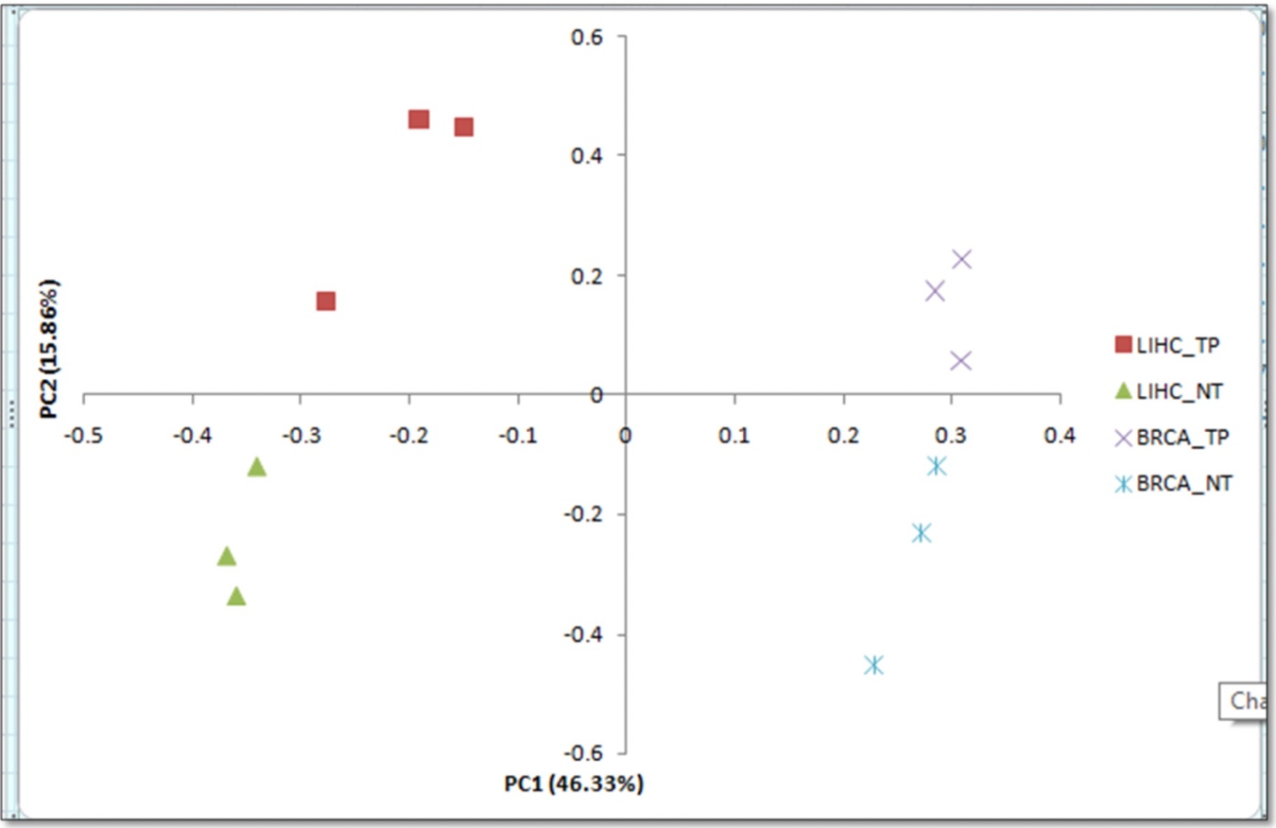Ploted the scatteredplot between two PCA components on the excel for better understanding of Genes.

Figure:- Shows the scatter plotof the given sample based on the principle of PCA (PS1)

& (PS2).

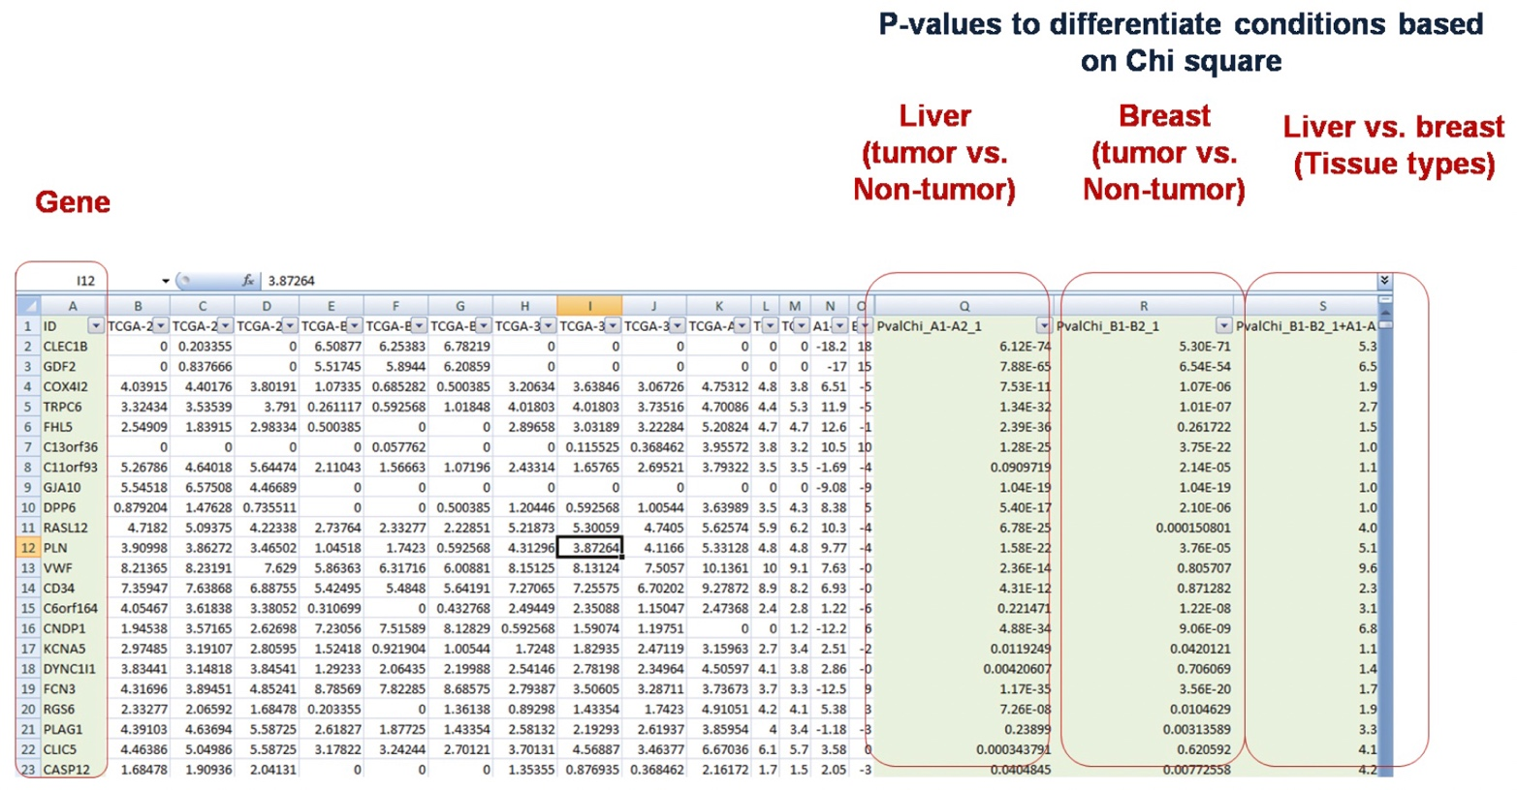**Factor Regression Analysis**

Figure:- Shows the result of factor regression analysis of TGCA (liver cancer vs breast cancer)

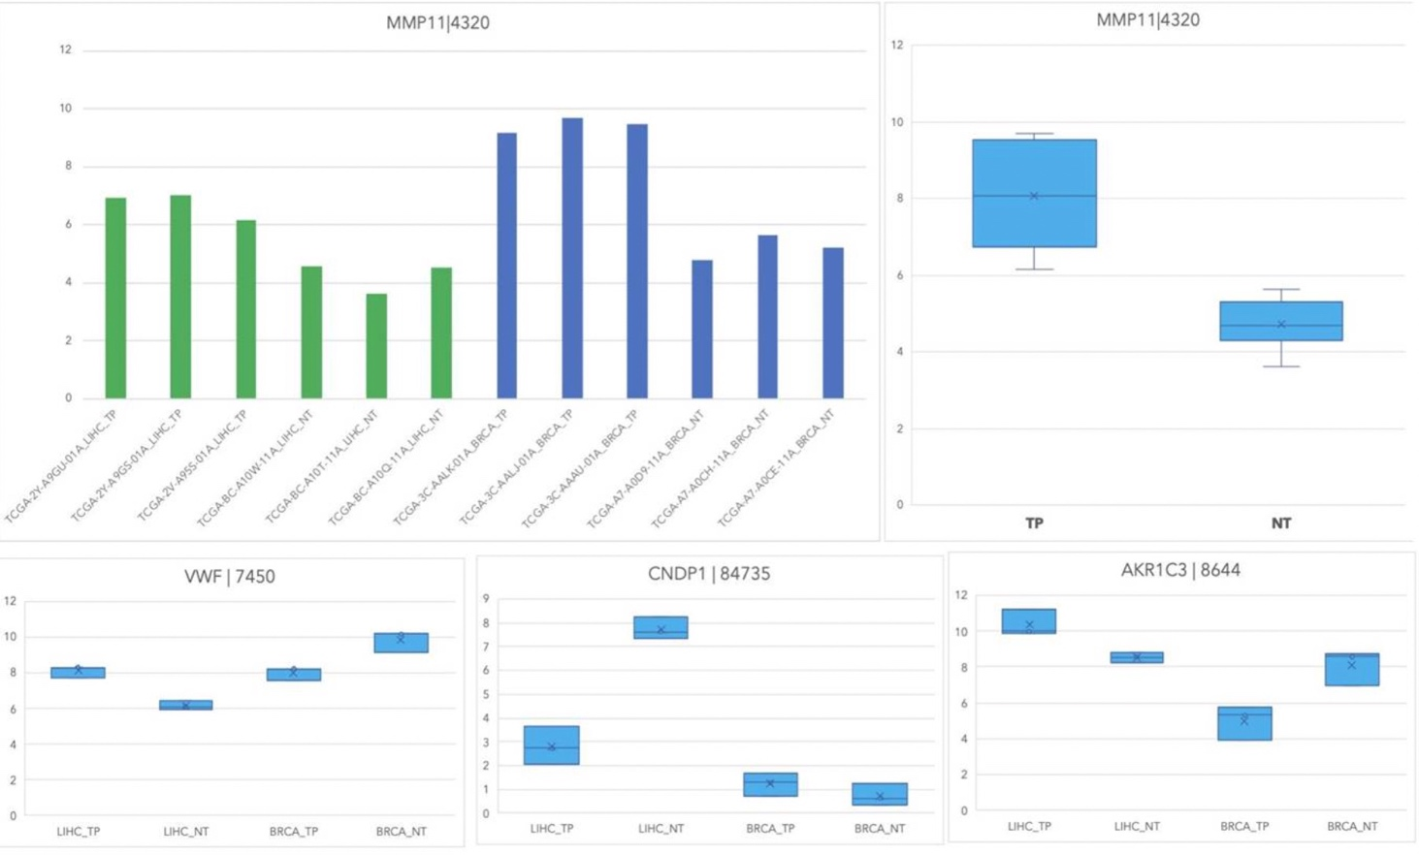Figure:- Shows the gene expression pattern using charts in four different conditions (Primary liver cancer, liver non-tumorous, Breast cancer, and non-tumorous breast tissues).

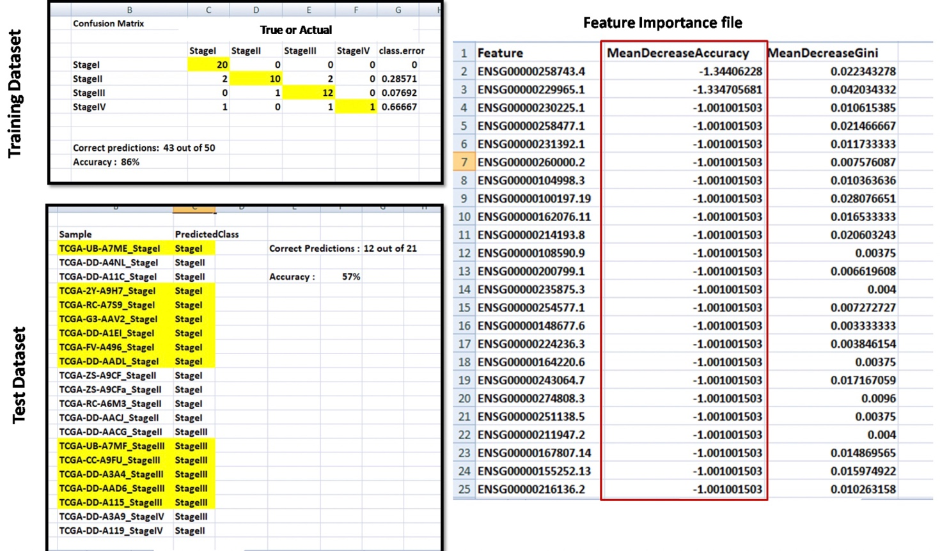**Stage Classification For Gene Expression**

Figure:- Shows the output of random forest classifier Prediction results on training (in form of confusion matrix) and Test Set with predicted class, and file of features with importance (or performance). Result of the prediction random tree based on all features that are responsible (12535).

**Stage Classification**

1. 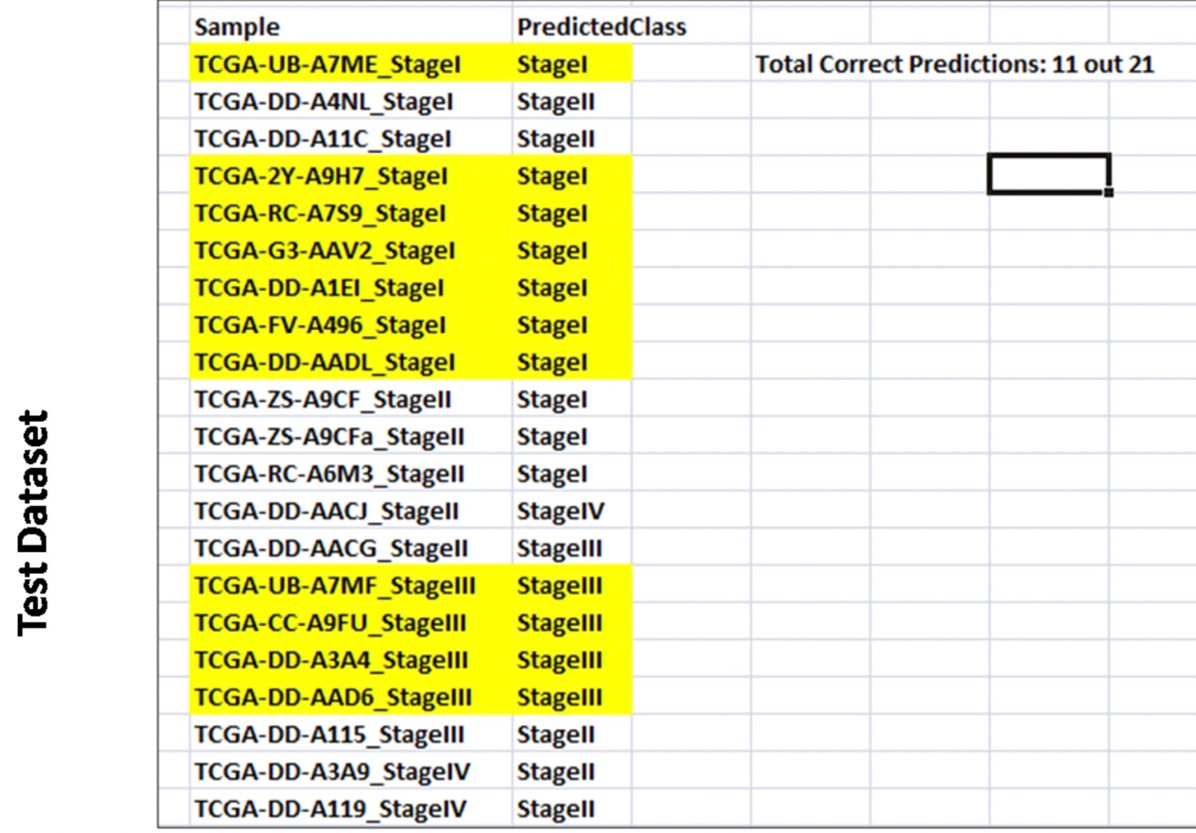**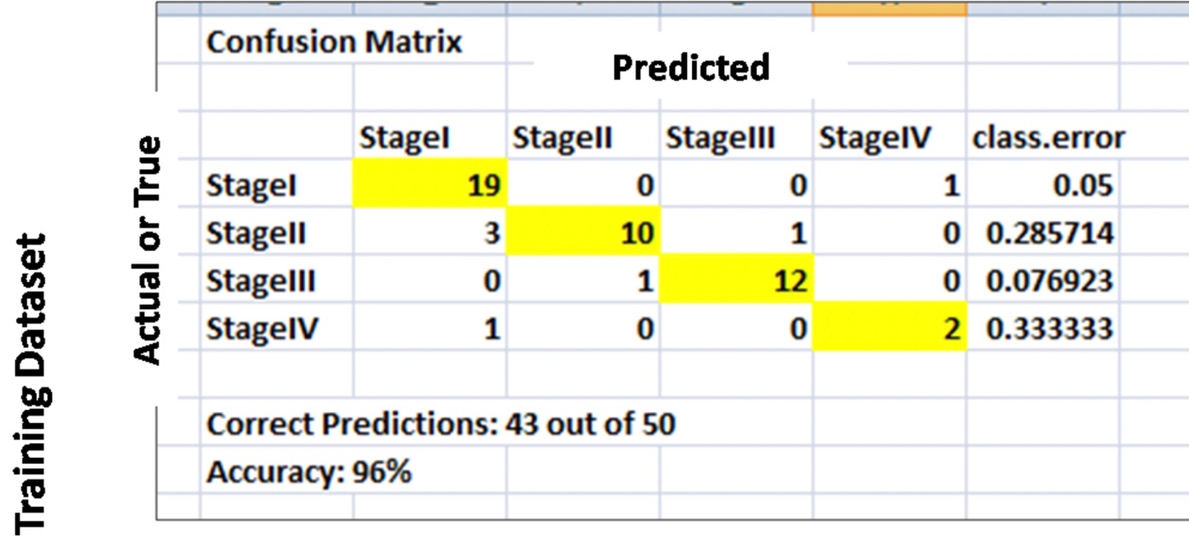Random Forest Model Based On Different Sets Of Genes**

Figure:- Shows the random forest of the matrix and predicted class.

1. 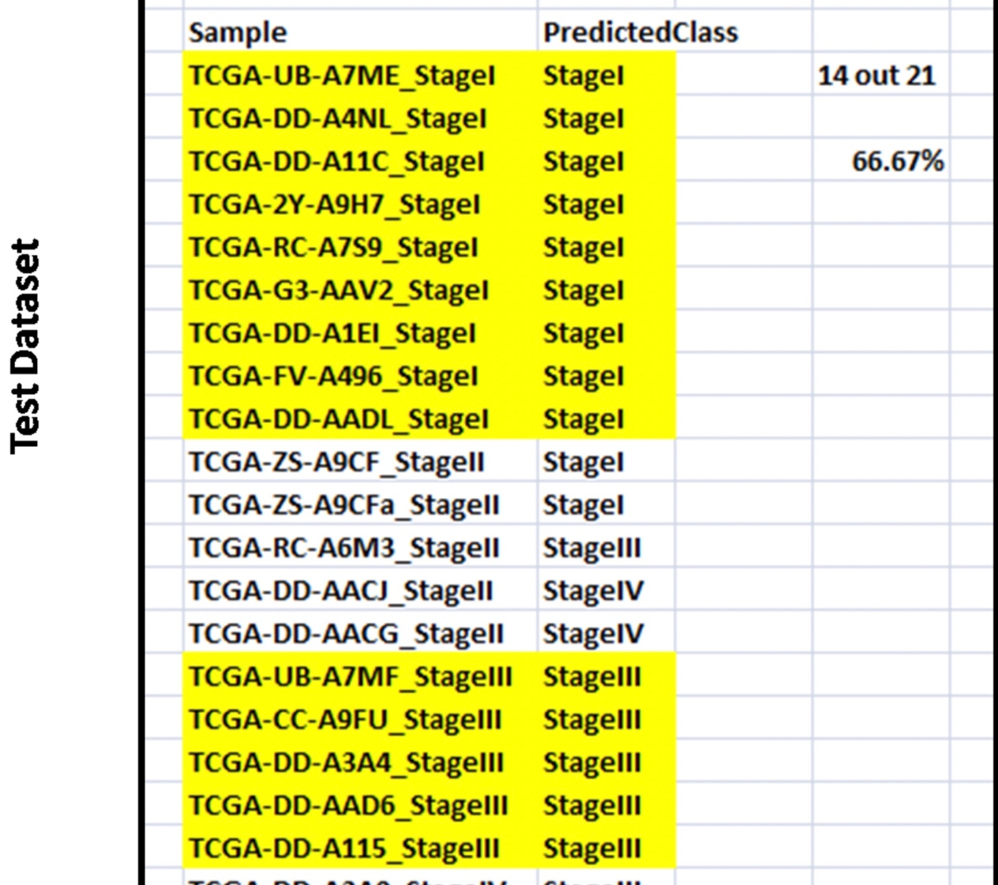**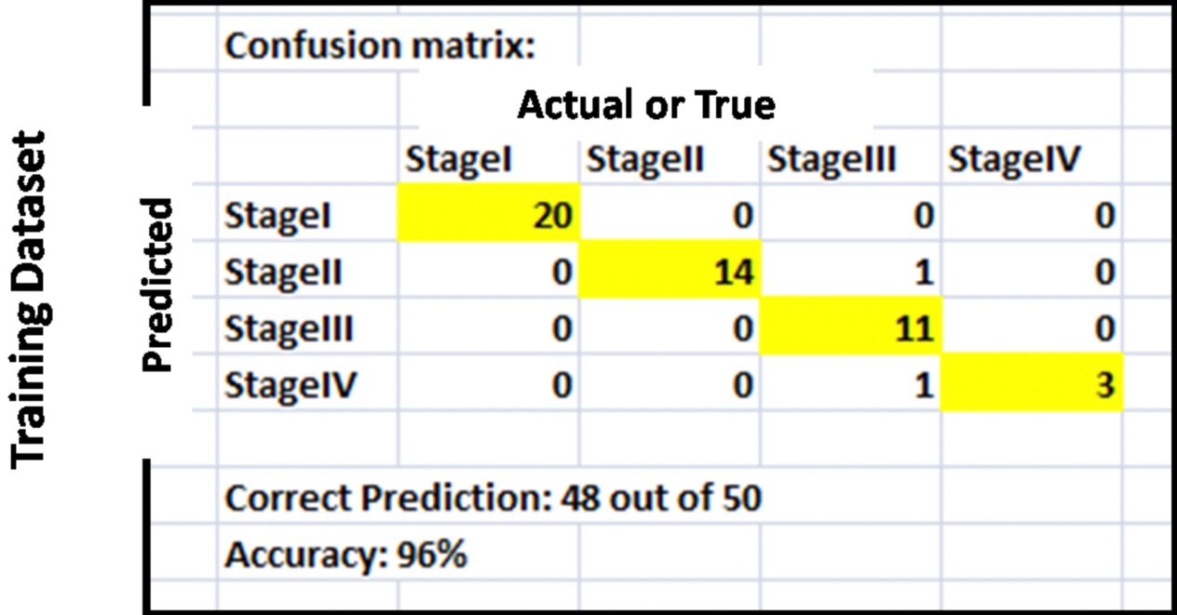SVM Based Model Selection Of Genes**

Figure:- Shows the result of SVM model for the matrix of different genes

1. 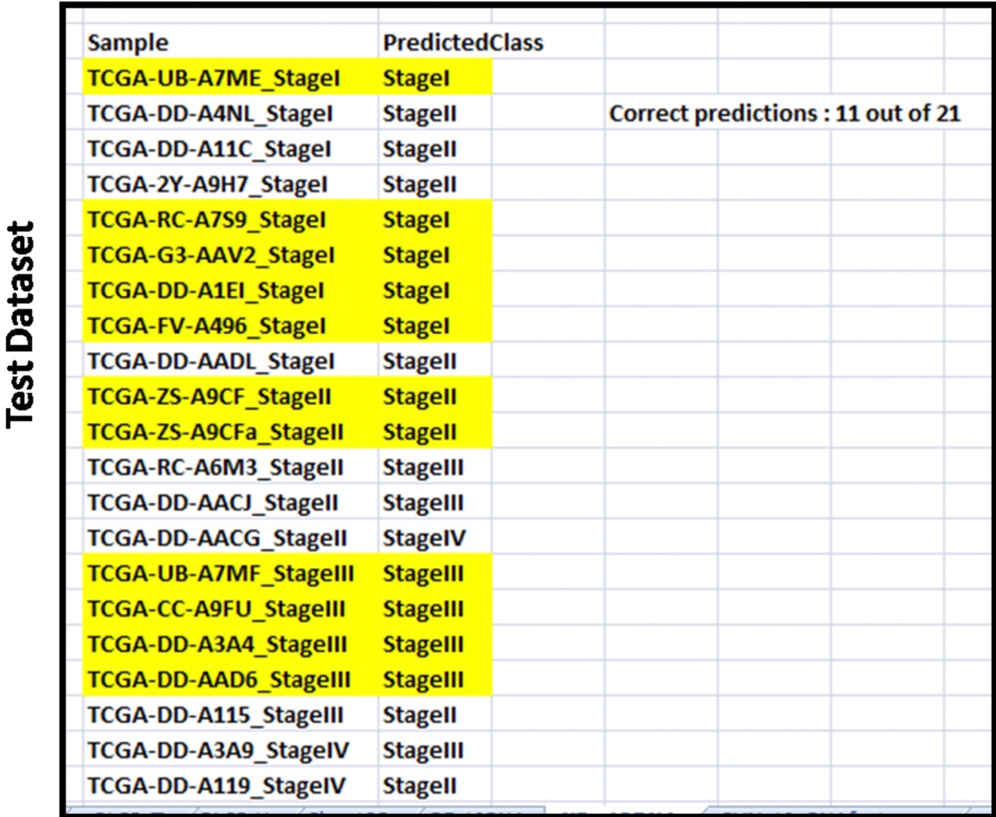**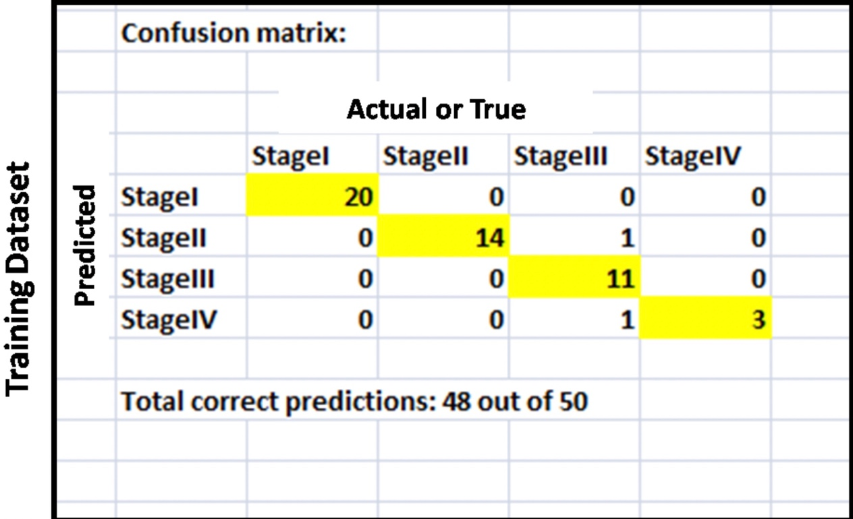Naïve Bayes Model Based On The Genes**

Figure:- Shows the result of naïve bayes model for the training set of gene matrix and the predicted data set.

1. 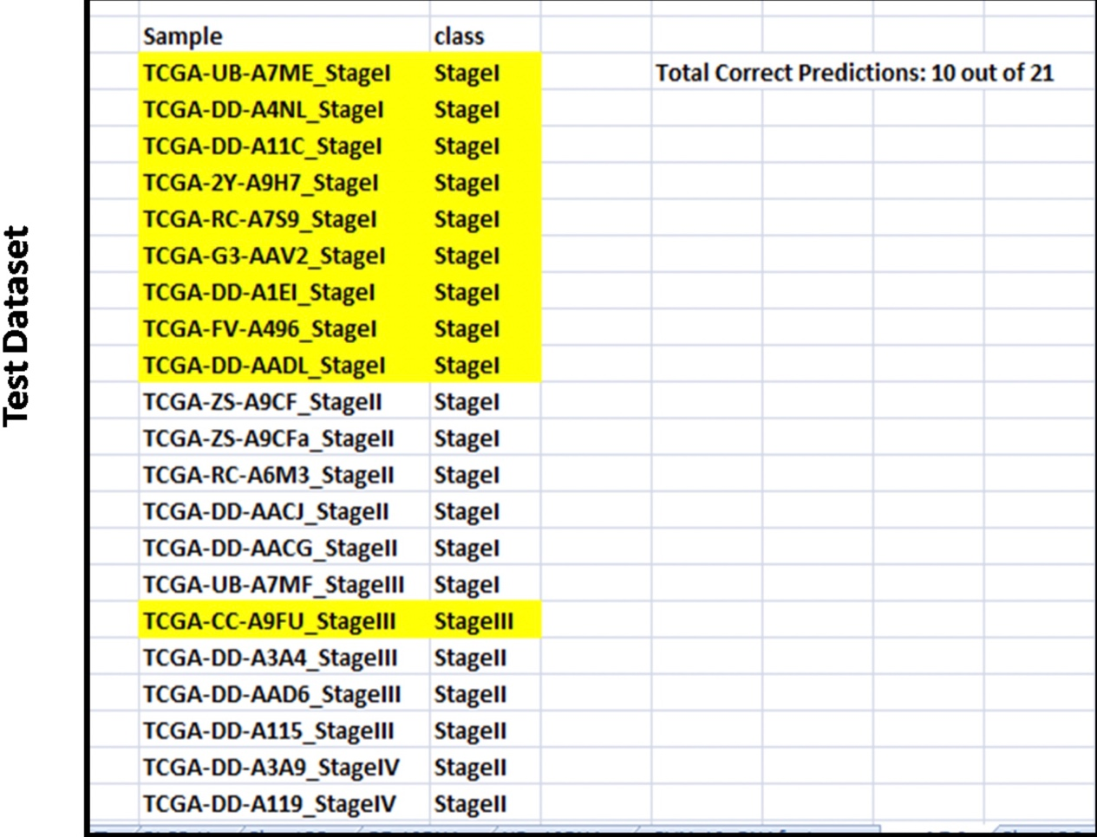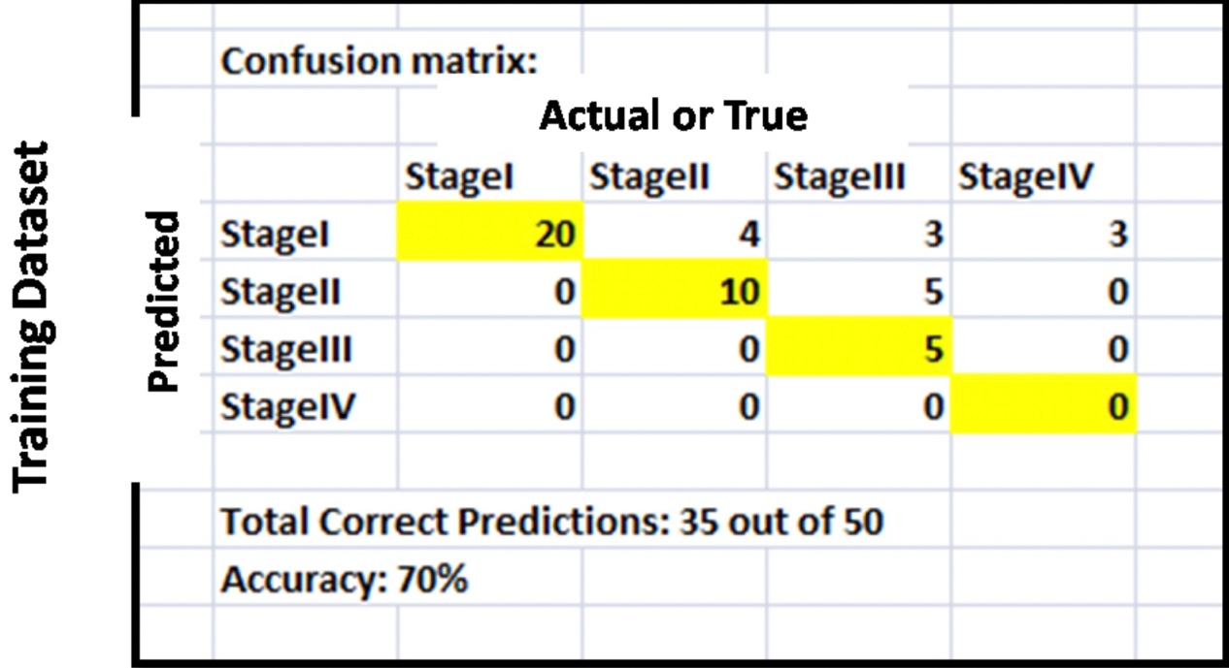**swLDA (Stepwise Linear Disriminant Analysis) Model For The Selected Genes.**

Figure:- Shows the result of swLDA model for the matrix and predicted genes.

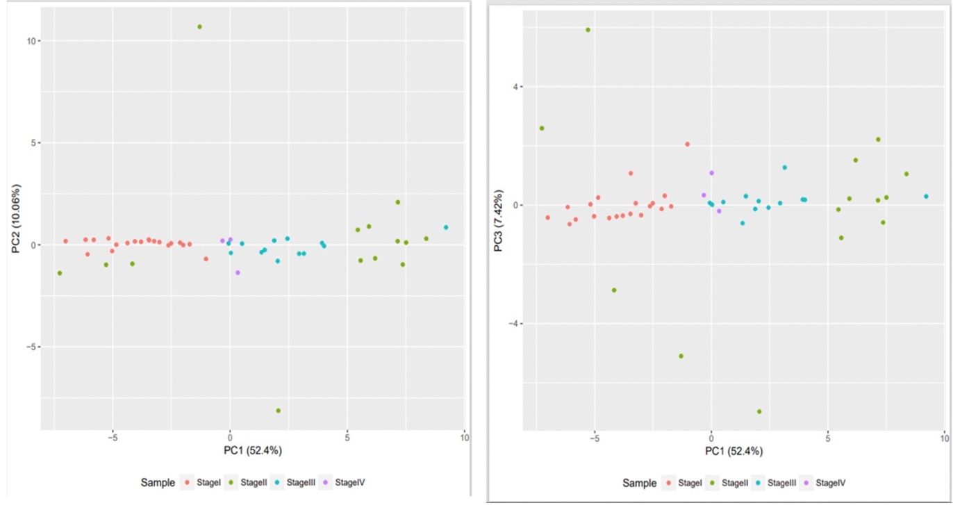**PCA With Selected Features**

Figure:-Shows PCA based on 40 selected features of LIHC sample based on different types of tumour stages.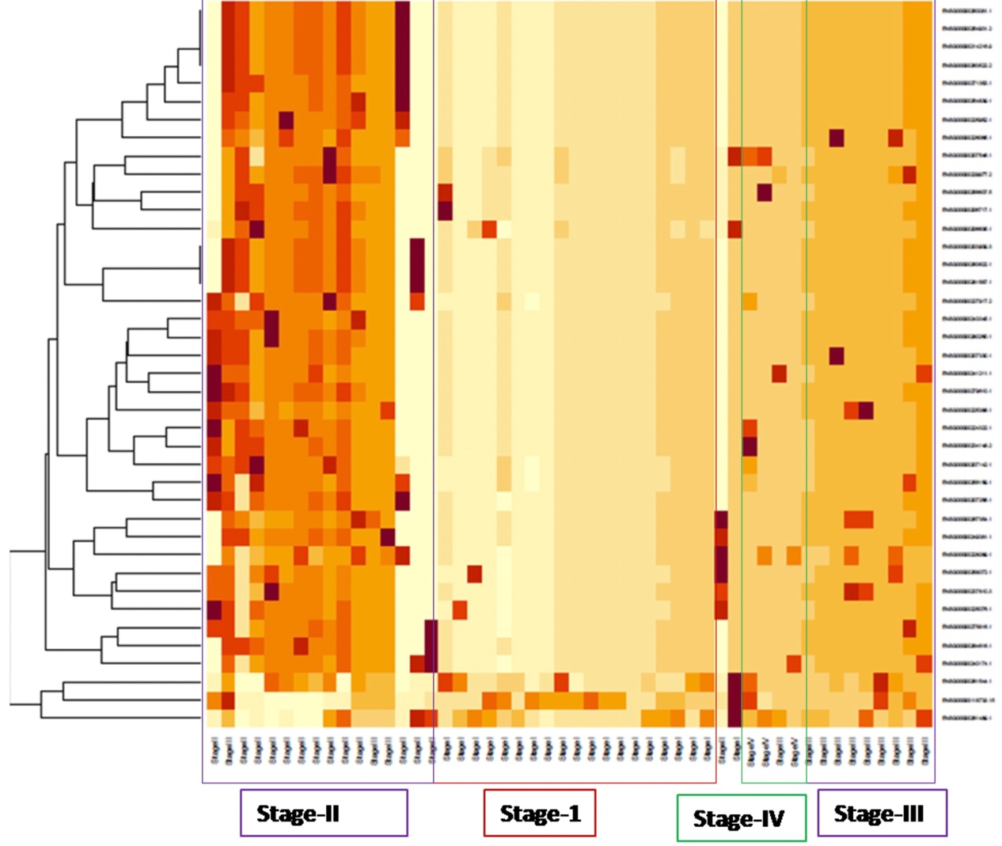

Figure:- Heatmap representing the expression pattern of genes.

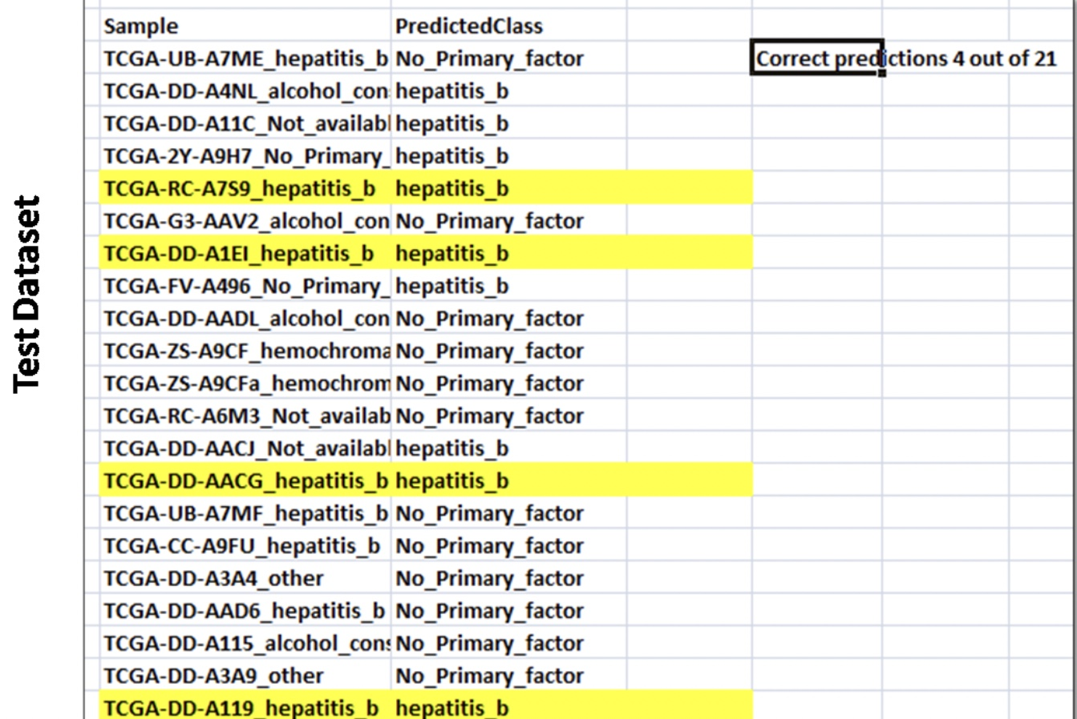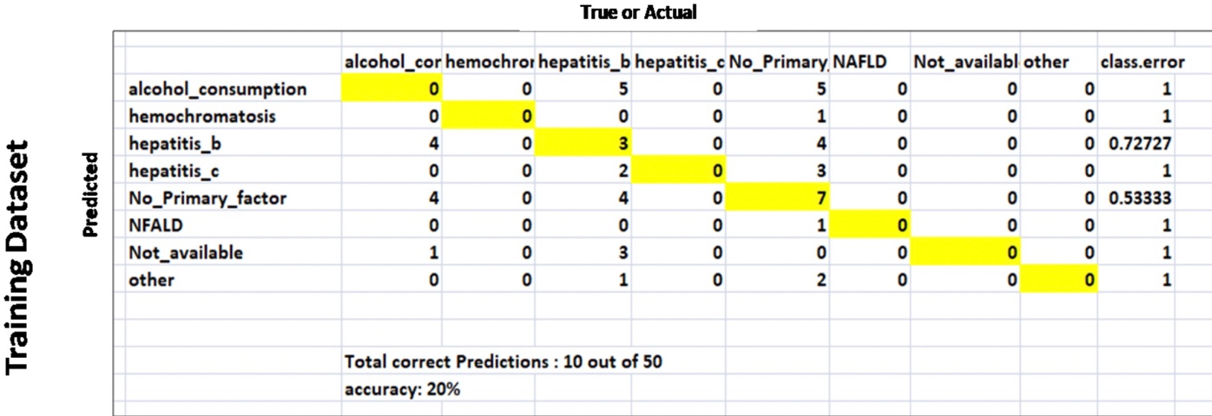**Classification of HCC samples (Risk factors) based on Gene Expression**

Figure:- Results shows the RF model for the classification of HCC-factor responsible for liver cancer.

**Risk Factor Classification**

1. 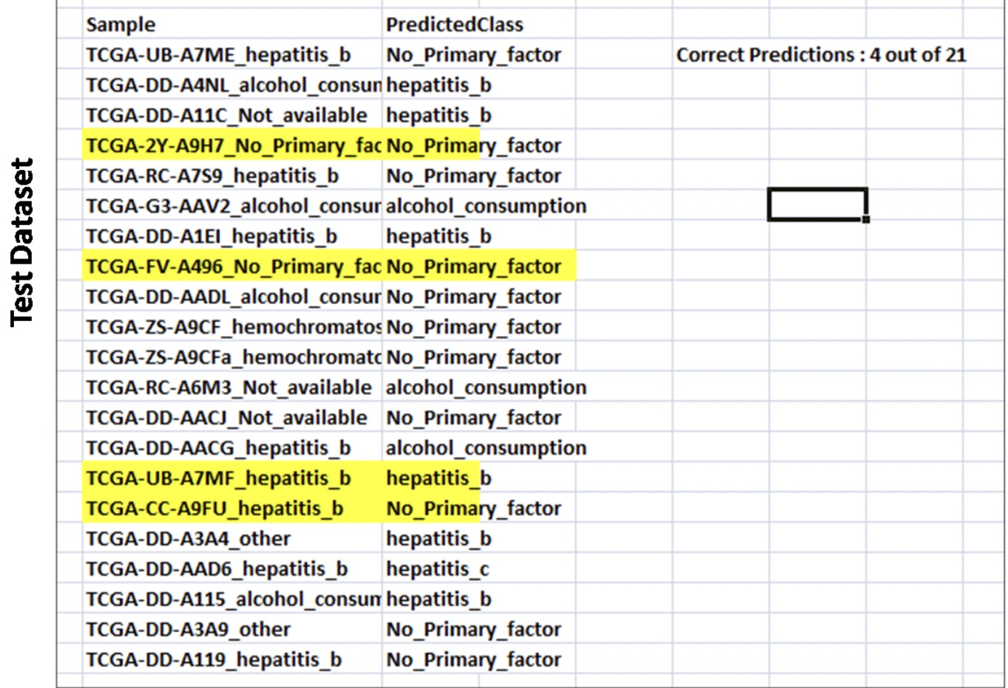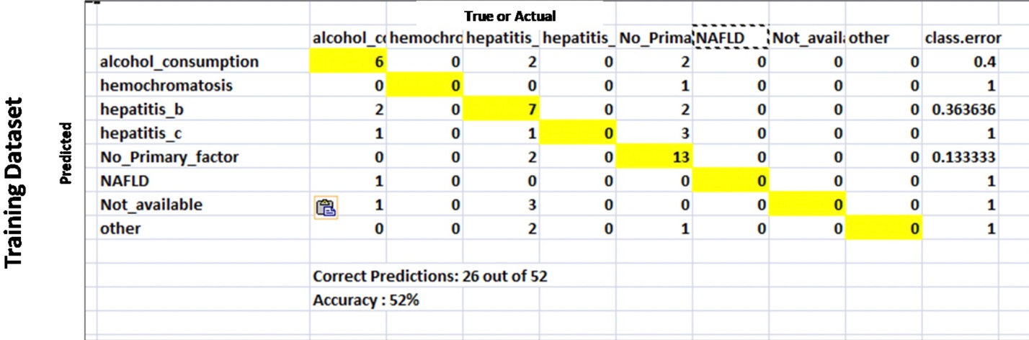**Random Forest Model Based On Selected Genes**

Figure:- Shows the result of RF model for the predicted data set (number of trees 500)

1. 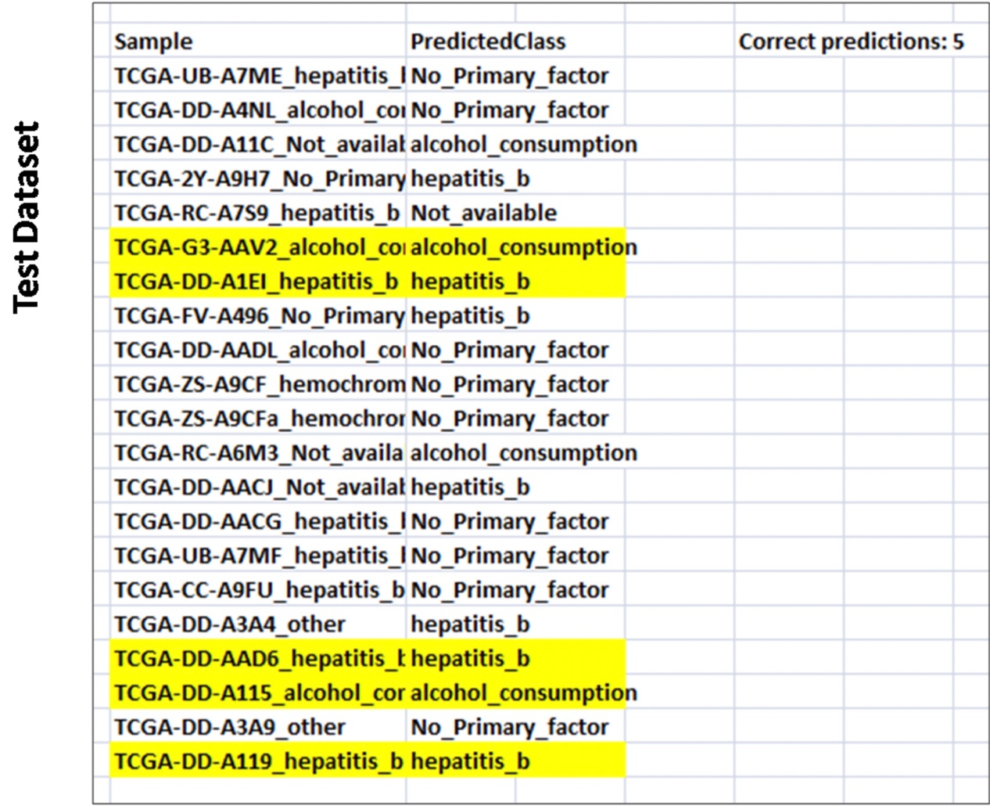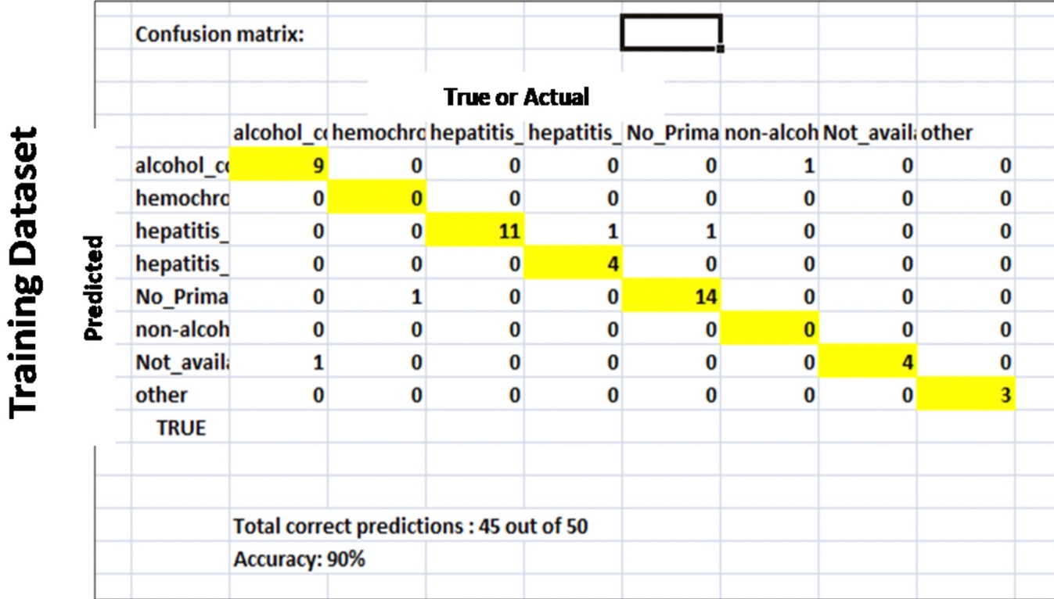**Navie Bayes Model Of Selected Genes**

Figure:- Results shows the navie bayes modeltraining setand predicted class of data set

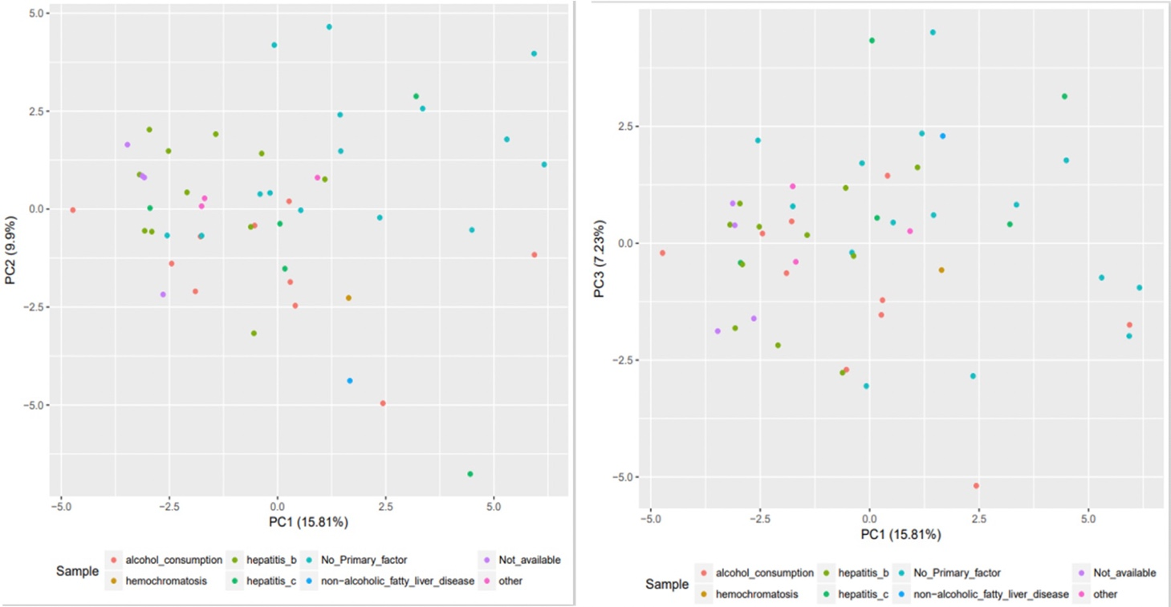**PCA Selection With Various HCC Risk Backgroung Based On 48 Selected Features**

Figure:- Visulization of samples based on PCA components from selected genes.

### **Build multi-omics pipeline using SNF tools**

It indicates that the P value off the Chi-square test. Chi-square test was performed in R to understand that clustering using omics-logic integration of data which represents different clinical factors.

Even though clinical phenotype like stage, risk factor or different vital stage are not signified which is obtained by clustering from the analysing data. The P value is higher than 0.05, but the parameters jeans/MiRNA or samples can vary by impact of this association.

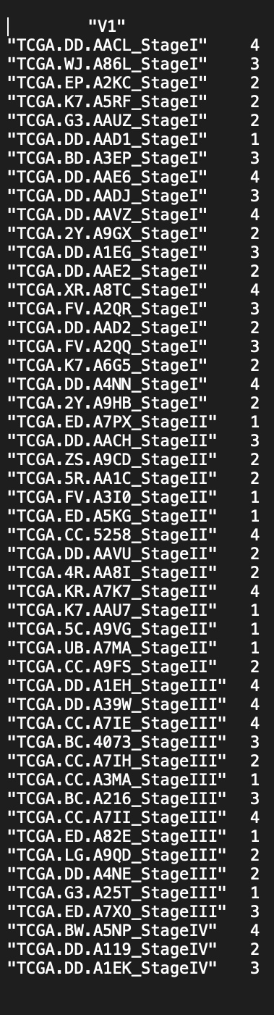

Based on the results of clusters we obtain from the SNF model analysis pipeline.

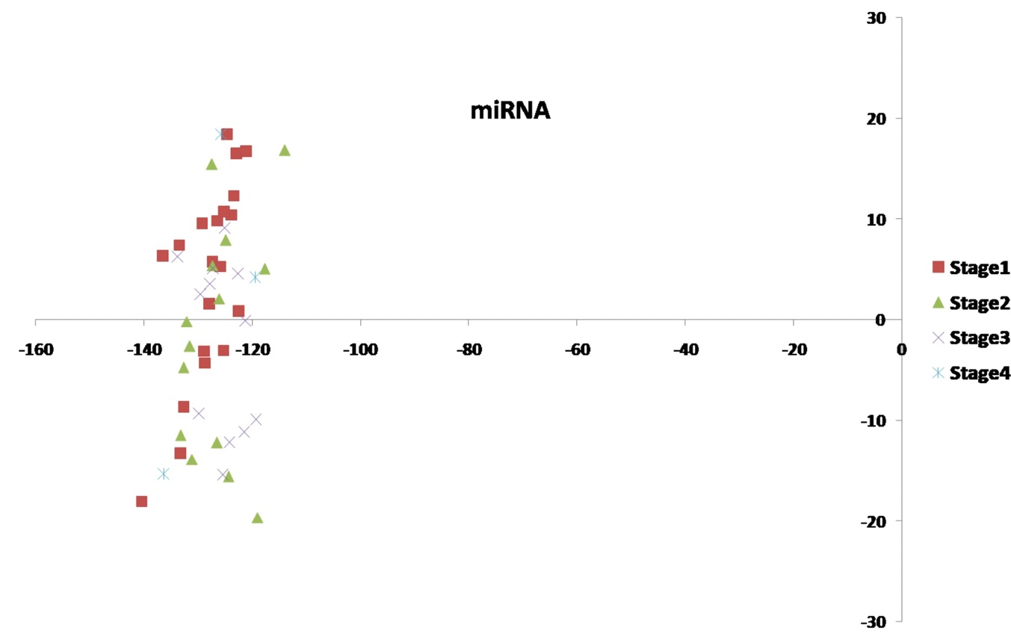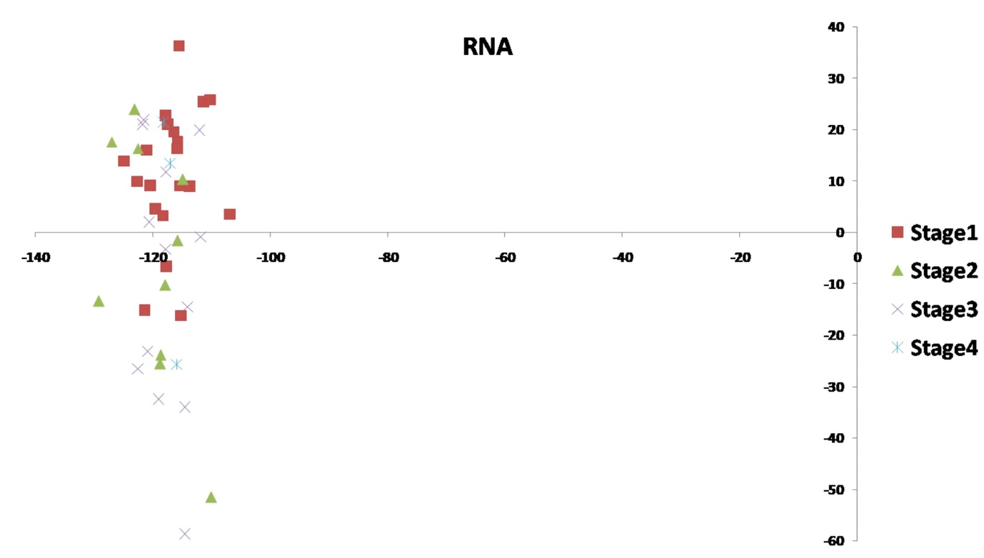**Build multi omics O2PLS pipeline**

Figure:- Shows the scatterplot of the tumour stages based on 2 components RNA & miRNA generated from O2PLS analysis.

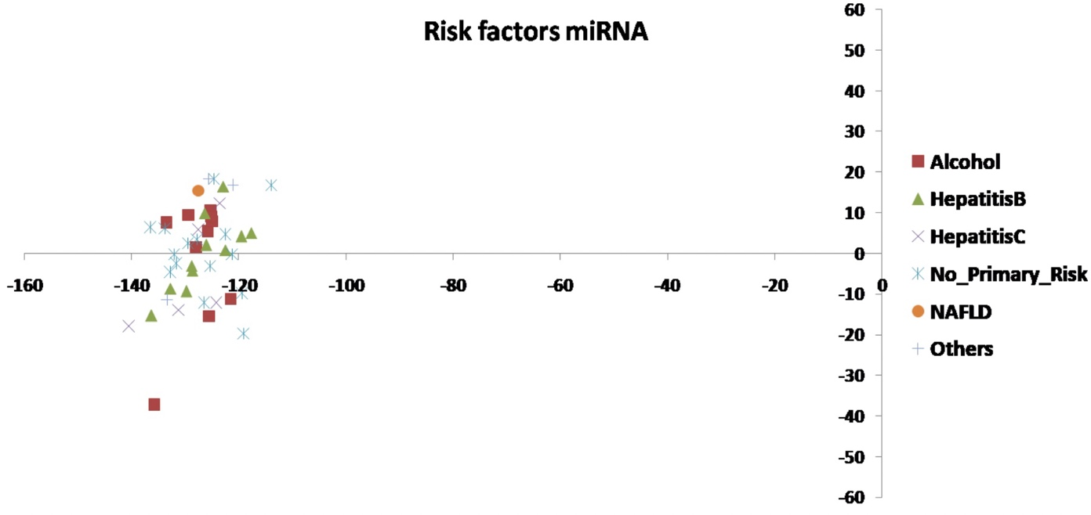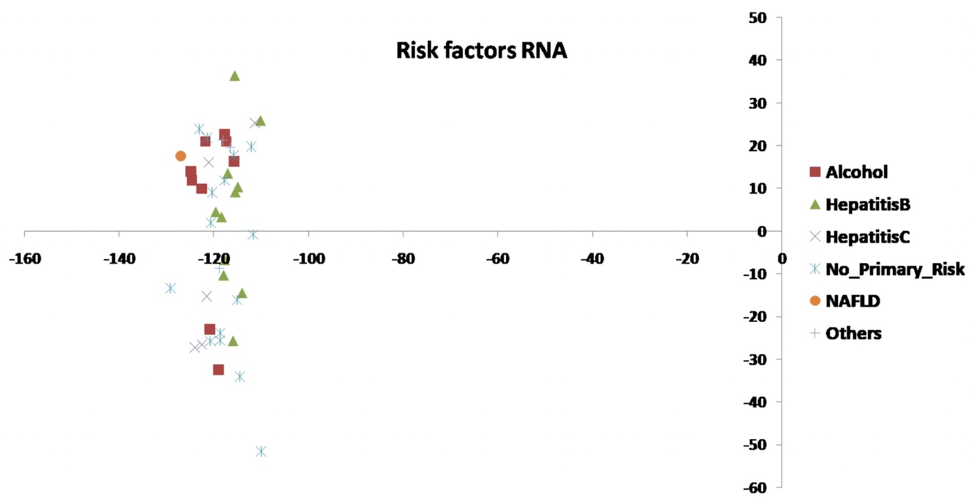**Risk Factors**

Figure:- Shows the scatterplot of the risk factor by HCC development based on 2 components RNA & miRNA using O2PLS analysis.

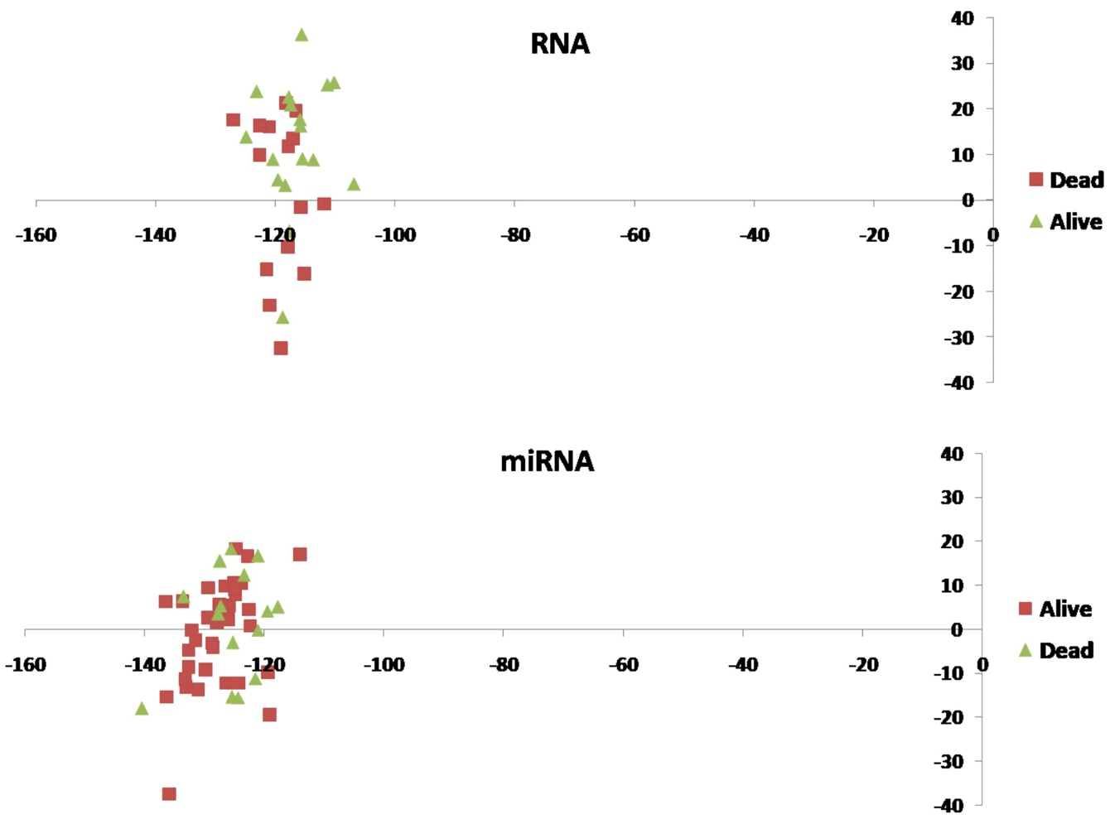Figure:- Shows the scatterplot for the vital state based on 2 components RNA & miRNA using O2PLS analysis.

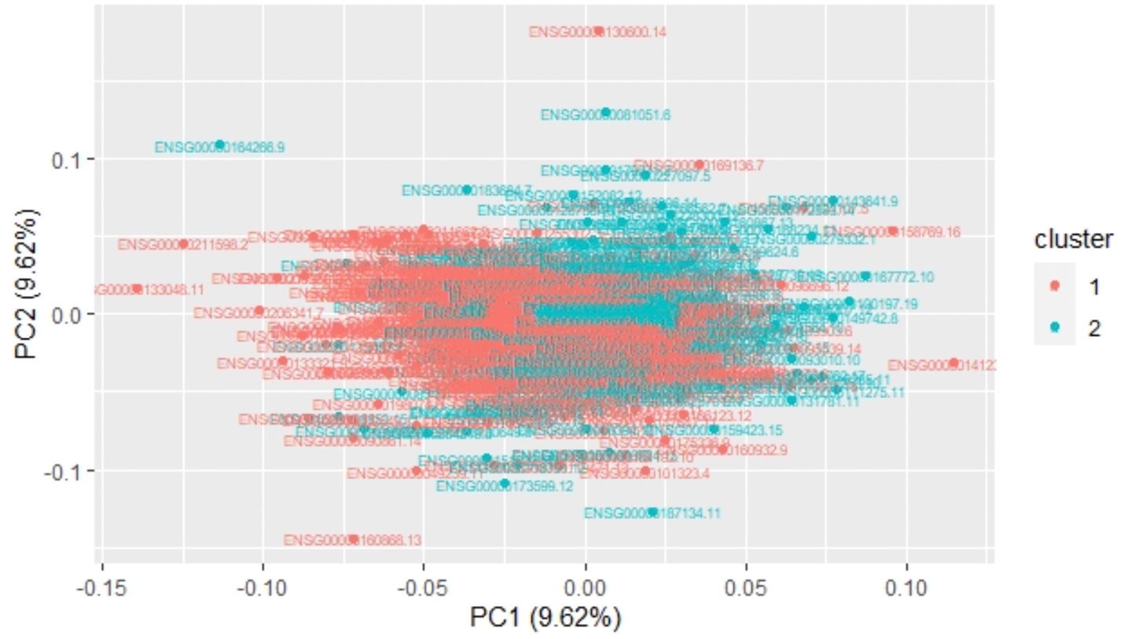**Using Clustering Features For Genes & miRNA Components From Omics-Logic.**

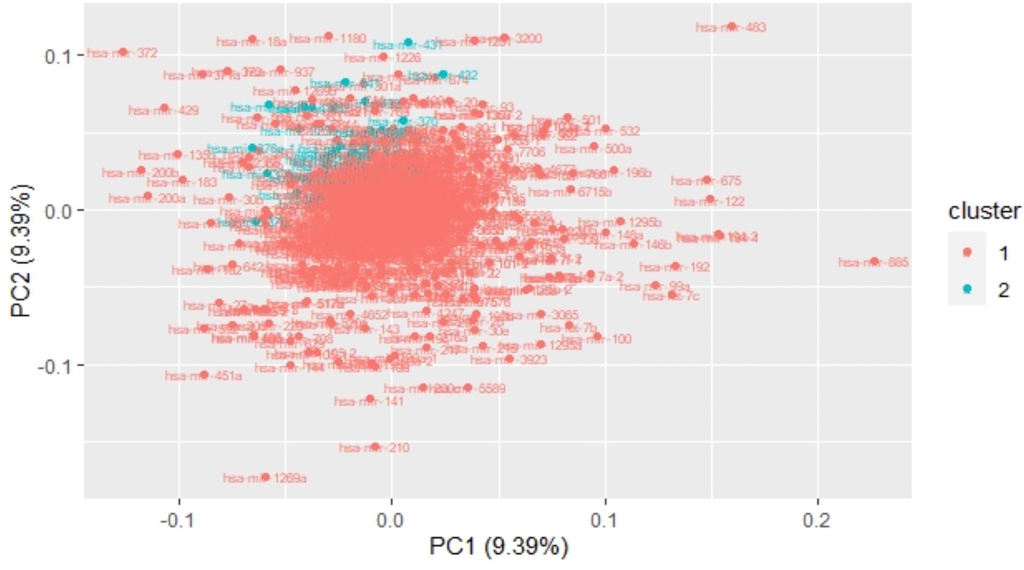Figure:- Shows the clusters of RNA(genes) Based on different components using O2PLS analysis.

Figure:- Shows the clusters of miRNA using O2PLS analysis.

**5 Conclusion and prospect**

Based PCA analysis we conclude 2 components PC1 & PC2 for the maximum variation of the data i.e nearly 60%. A Scatter plot scatter plot was drawn on the basis of 2 components (PS1 & PS2) which clearly indicates different clusters. We observed that 4 clusters are different from each other PCA analyse among different LIHC-TP samples from non tumours samples as well as breast cancer samples. The PCA analysis indicates major difference between tissue types. When regulating we can see VRF & AKRIC3 Primary liver cancer, while CNDP1 is down regulated in HCC Factors for non tumours, but regulated in comparision to breast cancer and non tumorous is cancer. The Confusion matrix of a training data predict the test date set and they are important files. The data was directly predicted 43 out of 50 samples of training data set and 12 samples out of 21 off the test dataset. The accuracy of model was achieved at 86% & 57% respectively. The performance is more responsible on training set, even though the features and numbers are very large.

Many bioinformatics tools were used like random forest, swLDA to characterise the features which is based on data with accuracy. It is limited to the features that contribute in increasing the accuracy, which creates the genes for the set for prediction.

On Selecting the 40 features, random forest performance remains the same for training and test set as random forest model is developed using 12,535 genes. An important points is to be considered that the number of features is reduced drastically which is less than 1% of the initial number of features. This indicate the importance in feature selection methods. Although a small number is more economically computational as well as practical implementation. It was observed that SVM model is the top performers among all the bioinformatics methods i.e Naïve Bayes, swLD, Random Forest, SVM accuracy is 96% for the training set and 66.7% for the test dataset.

The heat map clearly indicates that it has varying expression patterns of the following genes in stage 1 in comparison to different stages. Thus, few of the samples are already have mixed patterns. Mapping shows 40 RNA transcripts i.e 10 belong to LincRNA, 5miRNA, 4 anti-sense, 4 protein coding, 3SnRNA, 2MiscRNA, 1TEC & 2 sense introns. Different RNA types indicate dad they are employed to discriminate tumour stages.

On selecting 48 features, the performance of the models on training and test set data is increased with comparison to random forest using 12,535 genes. We conclude Naïve Bayes & SVM models attained accuracy of 90% and 70% respectively. The performance of the test set is measurable as only 5 samples out of 21 samples were correct and was predicted. The performance can be improved by selecting different parameters while algorithm is running. the number of trees vary which select different sets of features all different parameters can be used.

Based on the selected features, the samples very with various HCC factors in the background that are difficult to separate from each other. Thus to explore them different features which select different parameters while algorithm are running. Random forest have different number of trees that vary when selected in different sets of features, or different cuts are used to select another set of features that have better performance

**REFERENCES**

1. Bray F, Ferlay J, Soerjomataram I, Siegel RL, Torre LA, Jemal A. Global cancer statistics 2018: GLOBOCAN estimates of incidence and mortality worldwide for 36 cancers in 185 countries. CA Cancer J Clin. 2018 Nov;68(6):394-424. doi: 10.3322/caac.21492. Epub 2018 Sep 12. Erratum in: CA Cancer J Clin. 2020 Jul;70(4):313. PMID: 30207593.
2. Cancer Genome Atlas Research Network. Electronic address: wheeler@bcm.edu, & Cancer Genome Atlas Research Network (2017). Comprehensive and Integrative Genomic Characterization of Hepatocellular Carcinoma. Cell, 169(7), 1327–1341.e23. https://doi.org/10.1016/j.cell.2017.05.046
3. Attia, Y. M., Tawfiq, R. A., Ali, A. A., & Elmazar, M. M. (2017). The FXR Agonist, Obeticholic Acid, Suppresses HCC Proliferation & Metastasis: Role of IL-6/STAT3 Signalling Pathway. Scientific reports, 7(1), 12502. https://doi.org/10.1038/s41598-017-12629-4
4. Kaur, H., Bhalla, S., & Raghava, G. (2019). Classification of early and late stage liver hepatocellular carcinoma patients from their [genomics](https://edu.t-bio.info/glossary/genomics/) and epigenomics profiles. PloS one, 14(9), e0221476. https://doi.org/10.1371/journal.pone.0221476
5. Kaur, H., Dhall, A., Kumar, R., & Raghava, G. (2020). Identification of Platform-Independent Diagnostic [Biomarker](https://edu.t-bio.info/glossary/biomarker/) Panel for Hepatocellular Carcinoma Using Large-Scale Transcriptomics Data. Frontiers in [genetics](https://edu.t-bio.info/glossary/genetics/), 10, 1306. https://doi.org/10.3389/fgene.2019.01306
6. Zhang, Y., Gong, W., Dai, S., Huang, G., Shen, X., Gao, M., Xu, Z., Zeng, Y., & He, F. (2012). Downregulation of human farnesoid X receptor by miR-421 promotes proliferation and migration of hepatocellular carcinoma cells. Molecular cancer research : MCR, 10(4), 516–522. https://doi.org/10.1158/1541-7786.MCR-11-0473
7. He, J., Zhao, K., Zheng, L., Xu, Z., Gong, W., Chen, S., Shen, X., Huang, G., Gao, M., Zeng, Y., Zhang, Y., & He, F. (2015). Upregulation of microRNA-122 by farnesoid X receptor suppresses the growth of hepatocellular carcinoma cells. Molecular cancer, 14, 163. https://doi.org/10.1186/s12943-015-0427-9
8. Yang F, Gong J, Wang G, Chen P, Yang L, Wang Z. Waltonitone inhibits proliferation of hepatoma cells and tumorigenesis via FXR-miR-22-CCNA2 signaling pathway. Oncotarget. 2016 Nov 15;7(46):75165-75175. doi: 10.18632/oncotarget.12614. PMID: 27738335; PMCID: PMC5342731.
9. Gailhouste, L., Liew, L. C., Yasukawa, K., Hatada, I., Tanaka, Y., Kato, T., Nakagama, H., & Ochiya, T. (2019). MEG3-derived miR-493-5p overcomes the oncogenic feature of IGF2-miR-483 loss of imprinting in hepatic cancer cells. Cell death & disease, 10(8), 553. https://doi.org/10.1038/s41419-019-1788-6
10. Hepatitis B virus infection alters the transcriptional [regulation](https://edu.t-bio.info/glossary/gene-regulation/) of FXR-dependent microRNAs. DOI: https://doi.org/10.1016/S0168-8278(17)31873-1
11. Ma, X., Zhou, L., & Zheng, S. (2020). [Transcriptome](https://edu.t-bio.info/glossary/transcriptome/) analysis revealed key prognostic genes and microRNAs in hepatocellular carcinoma. PeerJ, 8, e8930. https://doi.org/10.7717/peerj.8930
12. Wang, B., Mezlini, A. M., Demir, F., Fiume, M., Tu, Z., Brudno, M., Haibe-Kains, B., & Goldenberg, A. (2014). Similarity network fusion for aggregating data types on a genomic scale. Nature methods, 11(3), 333–337. https://doi.org/10.1038/nmeth.2810
13. Mo, Q., Wang, S., Seshan, V. E., Olshen, A. B., Schultz, N., Sander, C., Powers, R. S., Ladanyi, M., & Shen, R. (2013). Pattern discovery and cancer gene identification in integrated cancer genomic data. Proceedings of the National Academy of Sciences of the United States of America, 110(11), 4245–4250. https://doi.org/10.1073/pnas.1208949110
14. Shen, R., Olshen, A. B., & Ladanyi, M. (2009). Integrative clustering of multiple genomic data types using a joint latent variable model with application to breast and lung cancer subtype analysis. Bioinformatics (Oxford, England), 25(22), 2906–2912. https://doi.org/10.1093/bioinformatics/btp543
15. Trygg J., & Wold Svante (2003). O2‐PLS, a two‐block (X–Y) latent variable regression (LVR) method with an integral OSC filter. https://doi.org/10.1002/cem.775
16. Subramanian, I., Verma, S., Kumar, S., Jere, A., & Anamika, K. (2020). Multi-omics Data Integration, Interpretation, and Its Application. Bioinformatics and biology insights, 14, 1177932219899051. https://doi.org/10.1177/1177932219899051
17. Das, T., Andrieux, G., Ahmed, M., & Chakraborty, S. (2020). Integration of Online Omics-Data Resources for Cancer Research. Frontiers in genetics, 11, 578345. https://doi.org/10.3389/fgene.2020.578345

**Pathways:**

1. JAK-STAT signaling pathway: https://www.kegg.jp/kegg-bin/highlight_pathway?scale=1.0&map=map04630&keyword=STAT3
2. Micro RNA in cancer pathway: https://www.kegg.jp/kegg-bin/show_pathway?query=miR22&map=map05206&scale=1.0&show_description=hide
3. Pathways in cancer (reference): https://www.kegg.jp/kegg-bin/highlight_pathway?scale=1.0&map=map05200&keyword=STAT3
4. Bile Secretion pathway: https://www.kegg.jp/kegg-bin/highlight_pathway?scale=1.0&map=map04976&keyword=fxr
5. Transcriptional misregulation in cancer (Cyclin A): https://www.kegg.jp/kegg-bin/highlight_pathway?scale=1.0&map=map05202&keyword=cyclinA